附件

Annex

**上海重点产业发展紧缺急需的技能型类职业**

**Urgently-Needed Skilled and Technical Professionals in Key Industries in Shanghai**

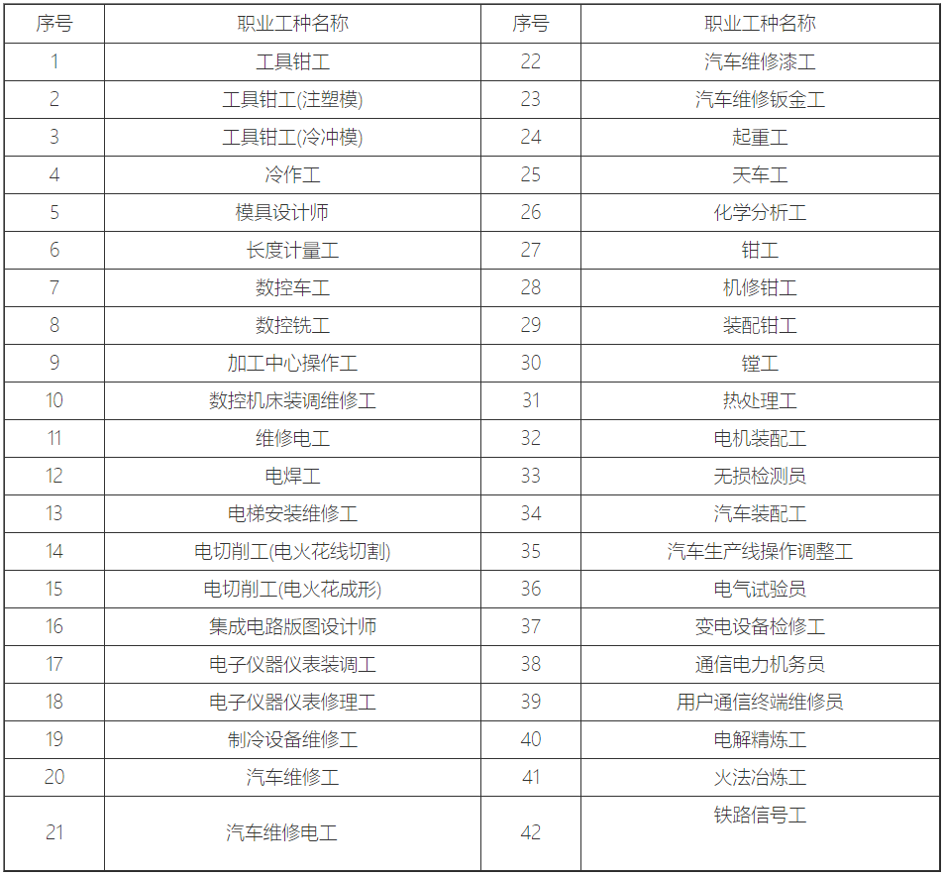

职业工种名称Occupation

工具钳工

Tool fitter

汽车维修漆工

Car paint repair specialist

工具钳工(注塑模)

Tool fitter (injection molding)

汽车维修钣金工

Car sheet metal repair specialist

工具钳工(冷冲模)

Tool fitter (cold stamping)

起重工

Crane operator

冷作工

Cold working specialist

天车工

Overhead crane operator

模具设计师

Mold designer

化学分析工

Chemical analyst

长度计量工

Length metrology engineer

钳工

Fitter

数控车工

CNC operator

机修钳工

Mechanical technician

数控铣工

CNC miller

装配钳工

Assembler

加工中心操作工

Machining center operator

镗工

Boring machine operator

数控机床装调维修工

CNC installation, commissioning and maintenance engineer

热处理工

Heat-treatment operator

维修电工

Maintenance electrician

电机装配工

Electrical mechanical assembler

电焊工

Electric welder

无损检测员

Nondestructive Inspection specialists

电梯安装维修工

Elevator installation and maintenance engineer

汽车装配工

Car assembler

电切削工(电火花线切割)

Electric cutting machine operator (wire electrical discharge machining)

汽车生产线操作调整工人

Auto production line operating adjustment engineer

电切削工(电火花成形)

Electric cutting machine operator (electrical discharge machining)

电气试验员

Electrical tester

集成电路版图设计师

Integrated circuit layout designer

变电设备检修工

Transformer repair specialist

电子仪器仪表装调工

Electrical and electronic measuring equipment installation and commissioning engineer

通信电力机务员

Communications and power maintenance engineer

电子仪器仪表修理工

Electrical and electronic measuring equipment repair specialist

用户通信终端维修员

Mobile terminal maintenance engineer

制冷设备维修工

Cooling equipment maintenance engineer

电解精炼工

Electrolytic refining engineer

汽车维修工

Auto mechanic

火法冶炼工

Pyrometallurgical engineer

汽车维修电工

Auto electrician

铁路信号工

Railway signal engineer